NEPAL COLLEGE OF INFORMATION TECHNOLOGY

Balkumari, Lalitpur

(Affiliated to Pokhara University)

A lab report

On

Subject :- Web Technology

Lab Report # 2

Title:- LINK TAGS

Submitted By:- Submitted to:-
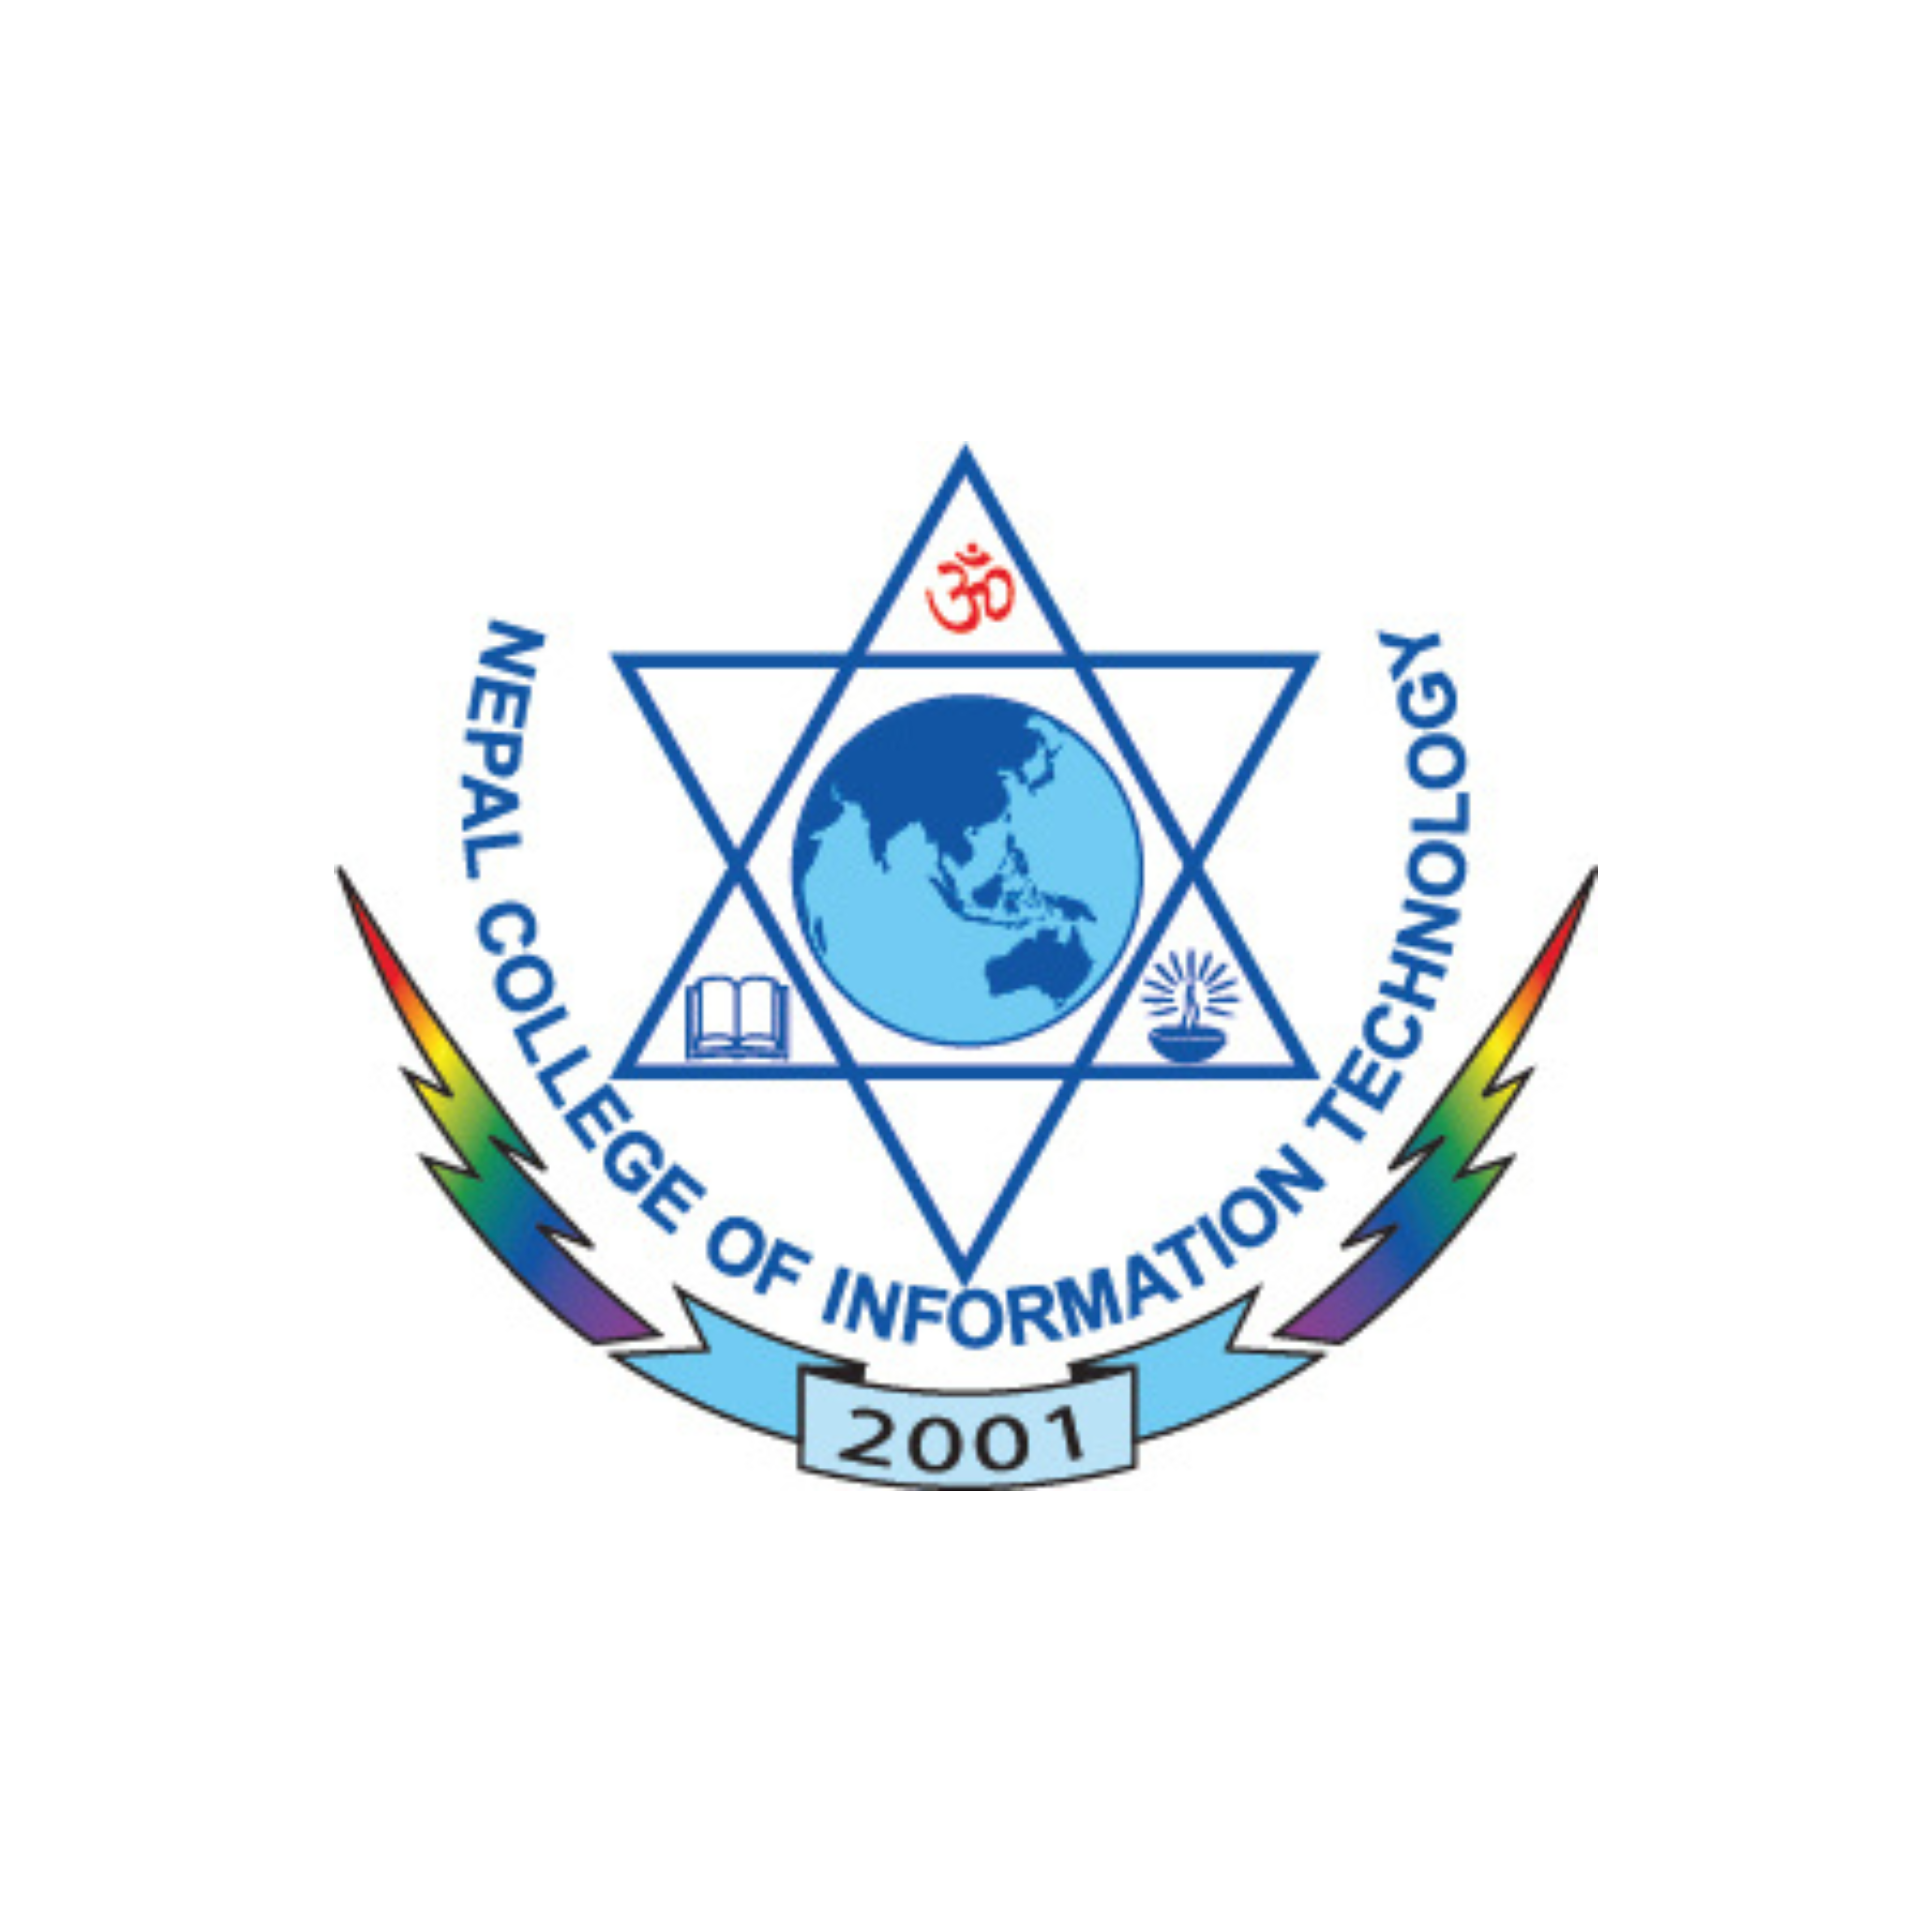
Name: Shahrish Mikrani Instructor: Er. Simanta Kasaju
Roll No: 241540 Department of IT
Faculty: Science and Technology Submissions date: 2026-09-09
Semester: 4th (DAY)

